BE AWARE – WE LIVE IN TICK COUNTRY
Created by the Town of Clinton Conservation Advisory Council from the following:
New York State Integrated Pest Management: www.dontgettickedny.org and www.nysipm.cornell.edu
Additional Resource: TickEncounter Resource Center – University of RI: www.tickencounter.org

Tick Identification – What Do Ticks Look Like?
https://nysipm.cornell.edu/whats-bugging-you/ticks/what-do-ticks-look/
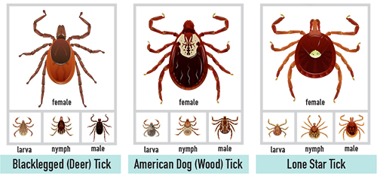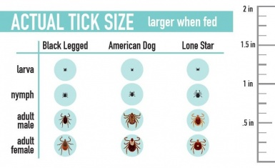

Why Should I Worry About Ticks?
https://nysipm.cornell.edu/whats-bugging-you/ticks/why-should-i-worry-about-ticks/
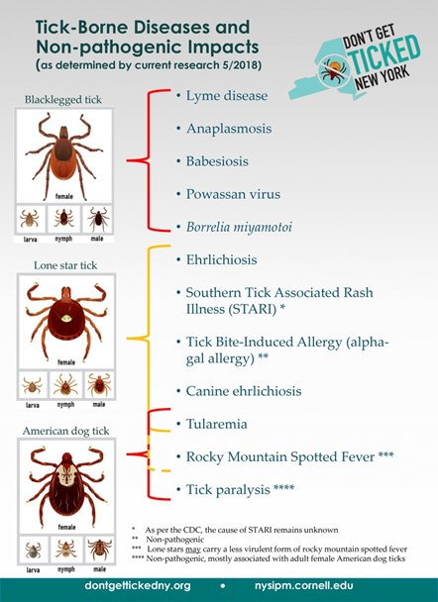 | 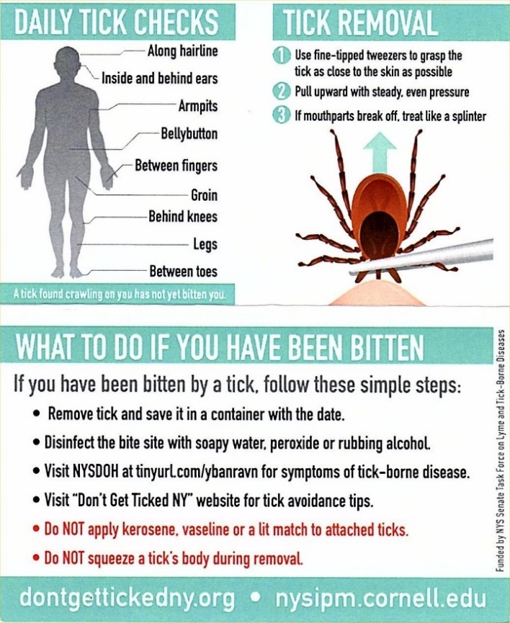

Tick FAQs
https://nysipm.cornell.edu/whats-bugging-you/ticks/tick-faqs/

Frequently Asked Questions About Ticks (printable .pdf)
https://nysipm.cornell.edu/sites/nysipm.cornell.edu/files/shared/documents/tick-FAQ-list.pdf

Why Do I Have Ticks In My Yard?
https://nysipm.cornell.edu/whats-bugging-you/ticks/why-do-i-have-ticks/

Life Cycle of the Black-Legged Tick (and Lyme Disease Prevention!)
https://www.youtube.com/watch?v=k5_5vM5aub4&feature=youtu.be

How Do I Protect Myself From Ticks?
https://nysipm.cornell.edu/whats-bugging-you/ticks/how-do-i-protect-myself-ticks/
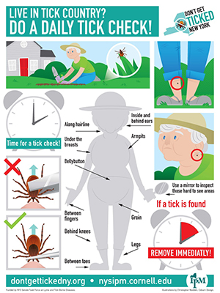 | 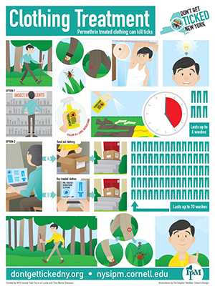
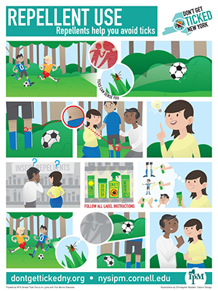 | 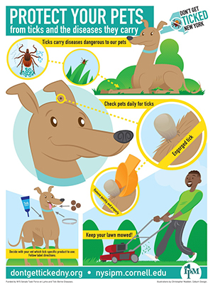
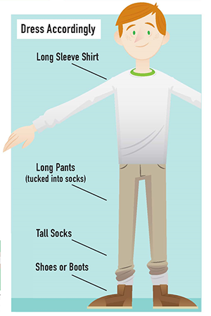 | 